REQUIREMENT ANALYSIS

Technology Stack (Architecture & Stack)
Date | 29 September 2026 | Team ID: [Enter Team ID]
Project Name: AI-powered FAQ and Customer Support Automation (AnswerBot)

Technical Architecture
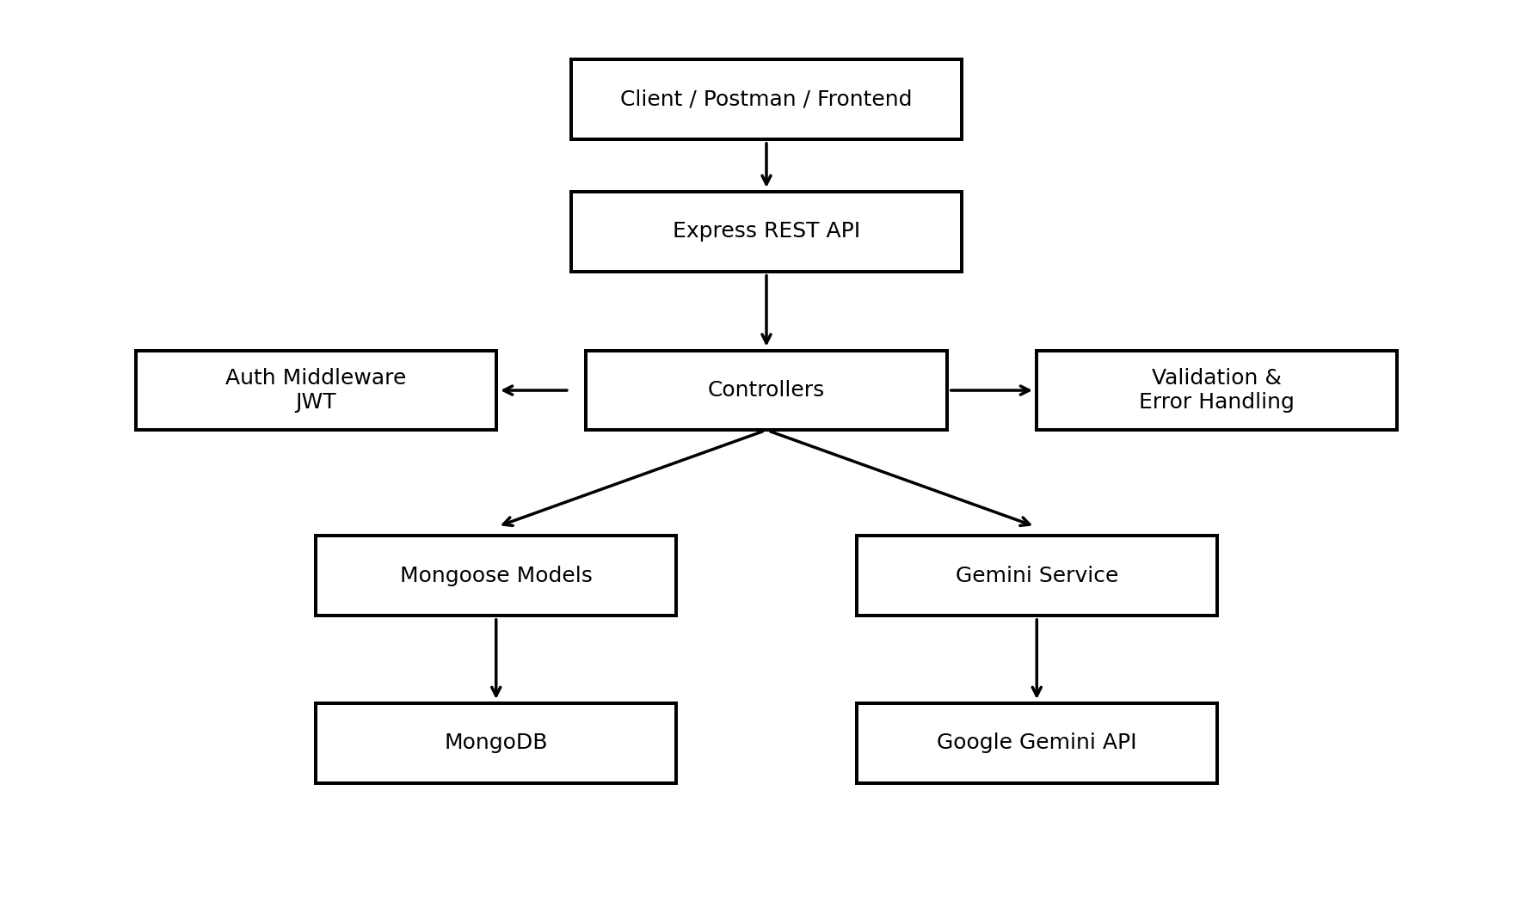

Table 1 - Components & Technologies
S.No | Component | Description | Technology
1 | User Interface / API Client | How users or frontends interact with the service | Postman / Thunder Client / future Web UI
2 | Application Runtime | Runs server-side JavaScript | Node.js 18+
3 | Web Framework | REST routing, middleware and HTTP handling | Express.js
4 | Database | Document storage for users and FAQs | MongoDB
5 | ODM | Schema modeling and validation | Mongoose
6 | Authentication | Stateless access tokens | JSON Web Token (JWT)
7 | Password Security | Password hashing | bcrypt
8 | External AI API | FAQ generation and language inference | Google Gemini via @google/genai
9 | Configuration | Environment-variable loading | dotenv
10 | Cross-Origin Access | API CORS headers | cors
11 | Development Runner | Automatic server restart during development | nodemon

Table 2 - Application Characteristics
S.No | Characteristic | Description | Technology
1 | Open-source Frameworks | Node.js ecosystem, Express and Mongoose support modular backend development. | Node.js / Express / Mongoose
2 | Security Implementations | JWT route protection, bcrypt hashing, authorization checks and sanitized error handling. | JWT / bcrypt
3 | Scalable Architecture | Headless stateless REST API; services can be separated or replicated as load increases. | Express REST architecture
4 | Availability | Can be deployed with a process manager, health checks and replicated database/cloud infrastructure. | Deployment dependent
5 | Performance | Lean JSON APIs; database indexes and query optimization can be applied to high-volume search. | MongoDB / Mongoose

